RD Fresh White Paper:

Optimizing Your Refrigeration
The Science of Passive Mineral-Based Food Preservation and its Impact on the Global Triple Bottom Line

Executive Summary
Food waste is a multi-layered crisis affecting global food security, corporate profitability, and environmental health. While traditional refrigeration focuses solely on temperature, it often ignores the chemical and atmospheric drivers of decay: ethylene gas, excess moisture, and microbial proliferation.
The RD Fresh "Food Insurance" Program introduces a proprietary mineral-based technology that stabilizes the storage environment. By extending produce shelf life by up to 50% and reducing refrigeration energy consumption, this technology provides a self-funding solution to one of the most significant inefficiencies in the modern supply chain.

1. The Problem: The High Cost of the "Status Quo"
Current cold chain management relies on mechanical cooling, which faces three primary challenges:
- Chemical Spoilage: Climacteric fruits and vegetables release Ethylene Gas (C2H4), a natural ripening hormone. In enclosed environments, C2H4 concentrations accelerate senescence (aging), leading to premature decay.
- Energy Inefficiency: High humidity in refrigeration units forces compressors to work harder to overcome latent heat. This leads to frequent "cycling," increasing electricity costs and equipment wear.
- Cross-Contamination: Standard refrigeration does little to mitigate odor transfer or the spread of airborne bacteria and mold spores between different food groups.

2. The Technology: Molecular Sieve Preservation
The core of the RD Fresh system is a 100% all-natural mineral mix designed to function as a molecular sieve.

2.1 Ethylene Scavenging
The mineral structure possesses a high surface-area-to-volume ratio, allowing it to adsorb ethylene molecules on a microscopic level. By maintaining sub-critical levels of C2H4 the technology effectively "silences" the chemical signal that triggers ripening.

2.2 Humidity and Latent Heat Management
Excess moisture is a primary carrier for bacteria and a major drain on refrigeration efficiency. RD Fresh minerals act as a desiccant, stabilizing relative humidity. This reduction in moisture allows the air to cool more rapidly, often resulting in a 3° to 5°F drop in internal temperature without adjusting the thermostat.

2.3 Antimicrobial and Odor Mitigation
The stabilization of the environment inhibits the proliferation of aerobic bacteria. By capturing Volatile Organic Compounds (VOCs), the system prevents "flavor transfer," ensuring the organoleptic integrity of stored products.
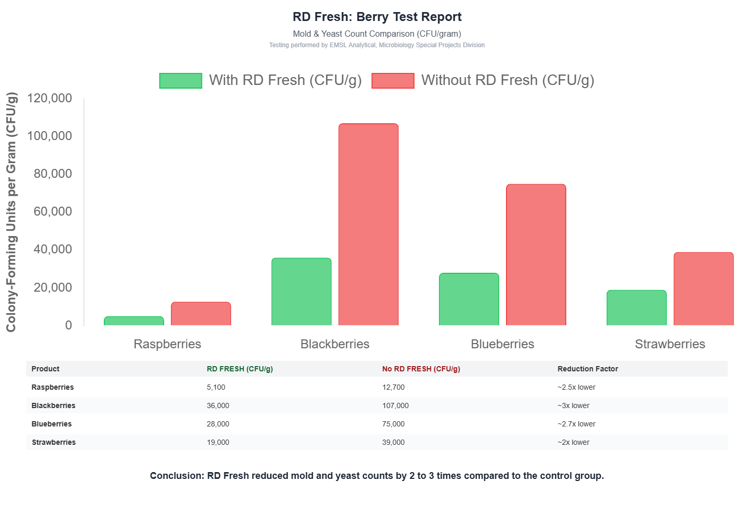
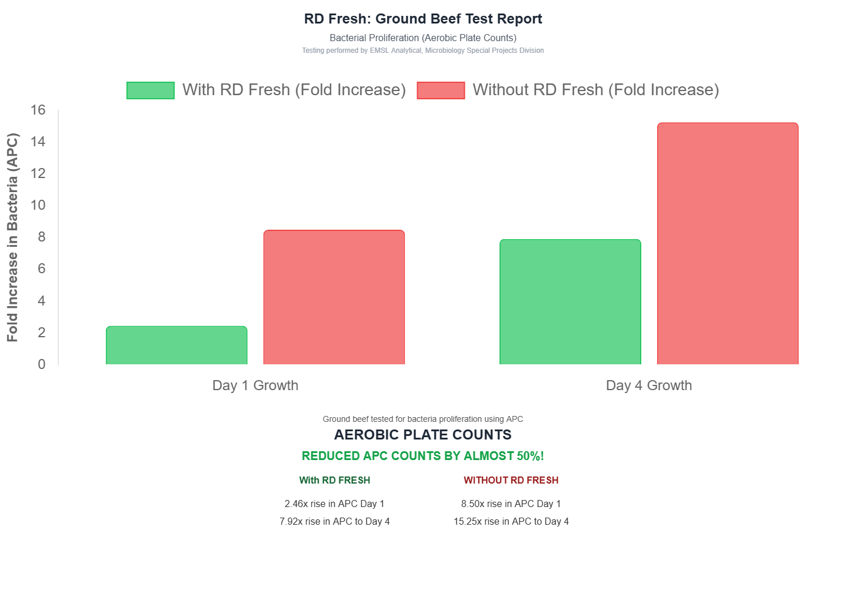

3. Operational Impact & Sustainability

3.1 Refrigeration Life Extension
By reducing the frequency of refrigeration cycles, RD Fresh significantly lowers the mechanical stress on the compressor.
- Energy Savings: Average reduction of 10–15% in kWh consumption.
- Asset Protection: Extends the mean time between failures (MTBF) for expensive cooling infrastructure.

3.2 The Circular Economy: A Zero-Waste Lifecycle
Unlike chemical preservatives or plastic-heavy solutions, the RD Fresh mineral mix is biologically inert and environmentally regenerative.
- Pre-use: Sourced from natural mineral deposits.
- During use: Non-toxic and food-safe.
- Post-use: 100% recyclable as a soil amendment (fertilizer), returning essential minerals to the earth to support future crop growth.

4. Conclusion
The RD Fresh "Food Insurance" Program represents a paradigm shift in food logistics. By moving away from reactive "waste management" toward proactive "atmospheric stabilization," businesses can capture lost revenue while simultaneously meeting ESG (Environmental, Social, and Governance) mandates.
Key Takeaway: For less than the cost of current waste-disposal fees, RD Fresh provides a measurable, scientific safeguard for the world’s most perishable assets.

